Screen Shots

**Welcome Screen/ Admin Home Page:**

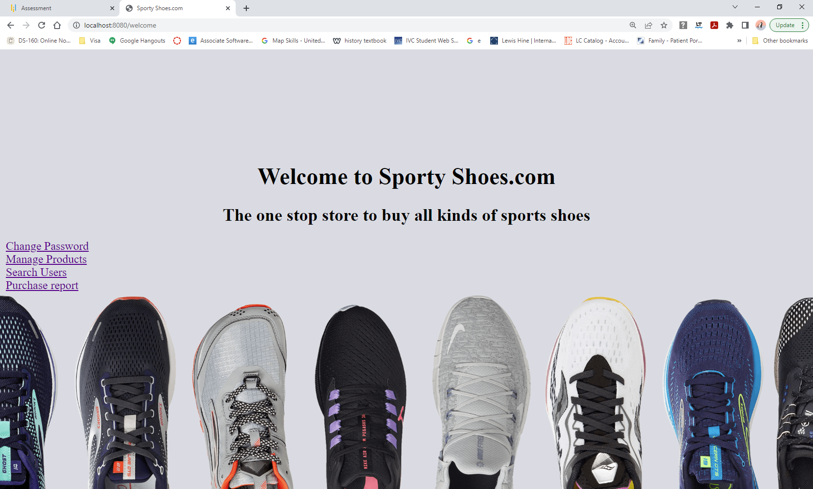

**Change Password Page:**

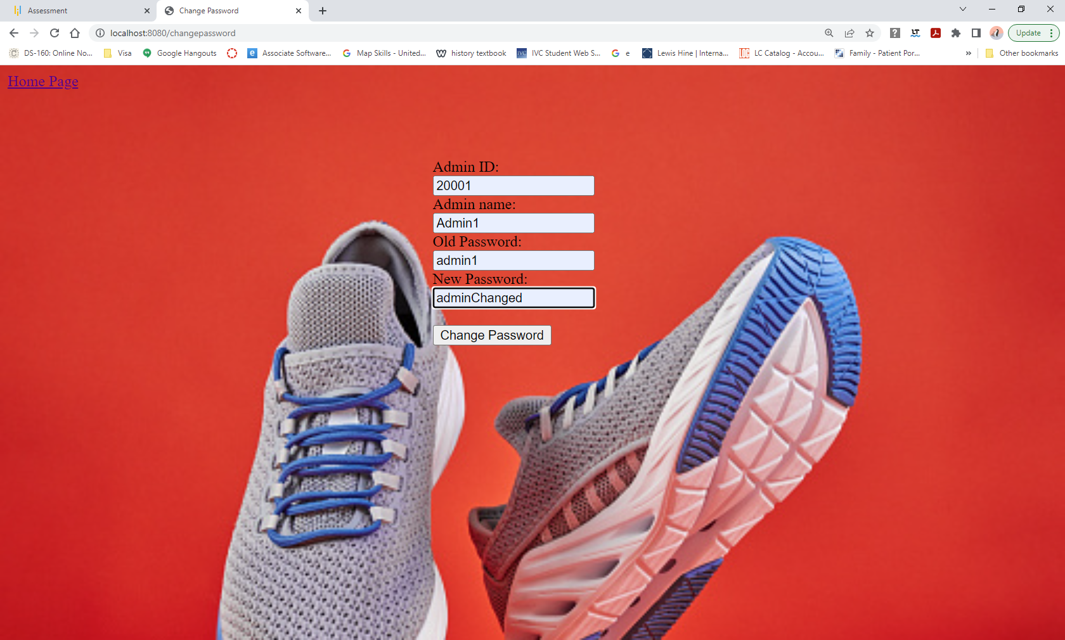

**Password Changed Message Page :**

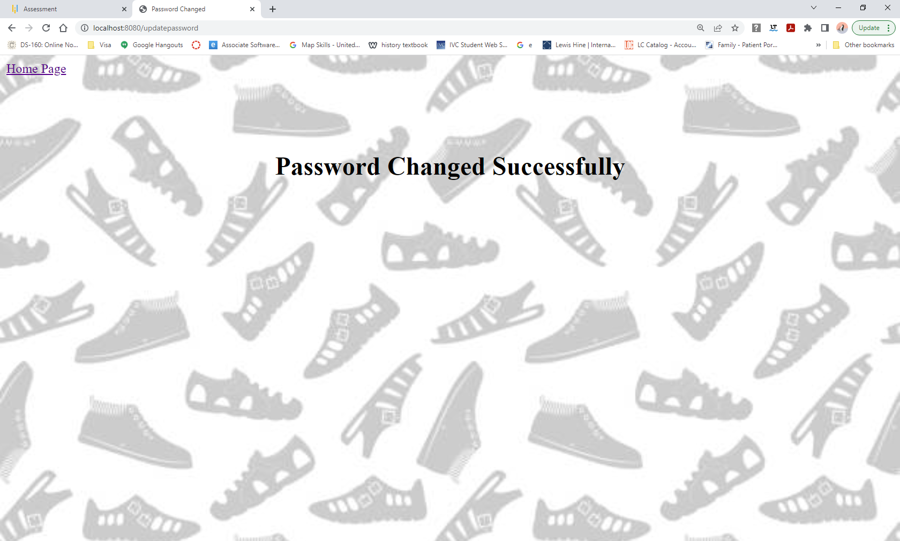

**Product Manager Page:**

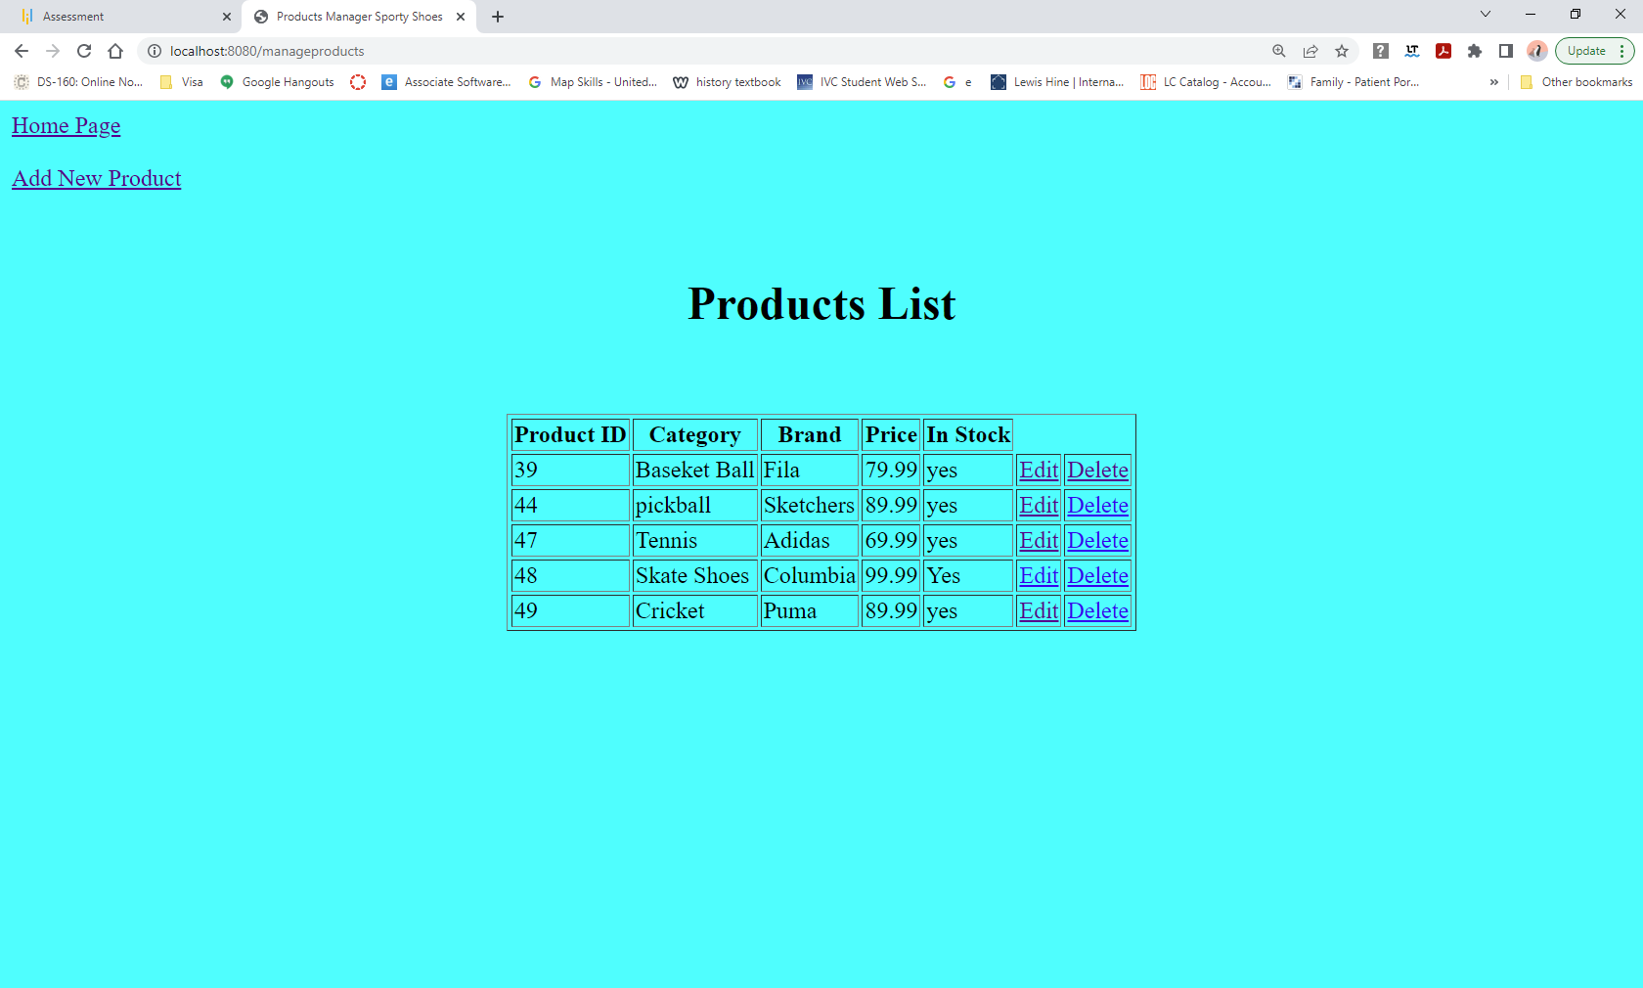

**Add New Product Page:**

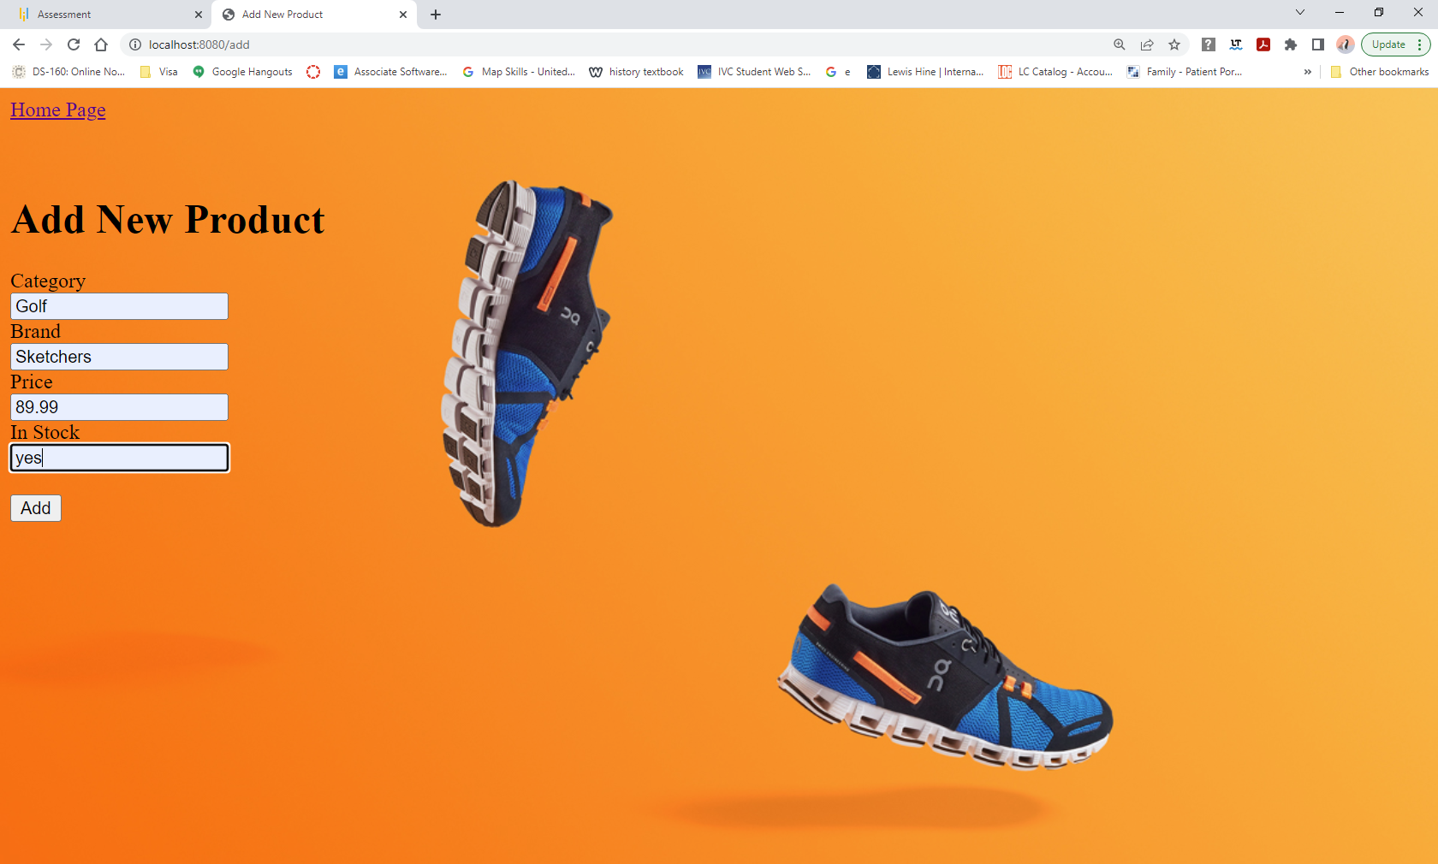

**New Product Added Successfully Message Page:**

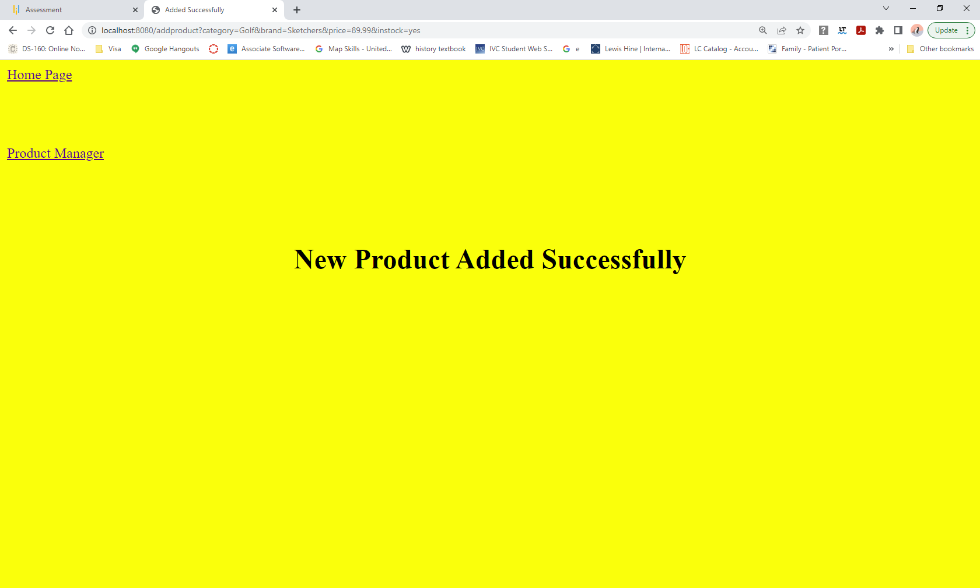

**Edit Product Page:**

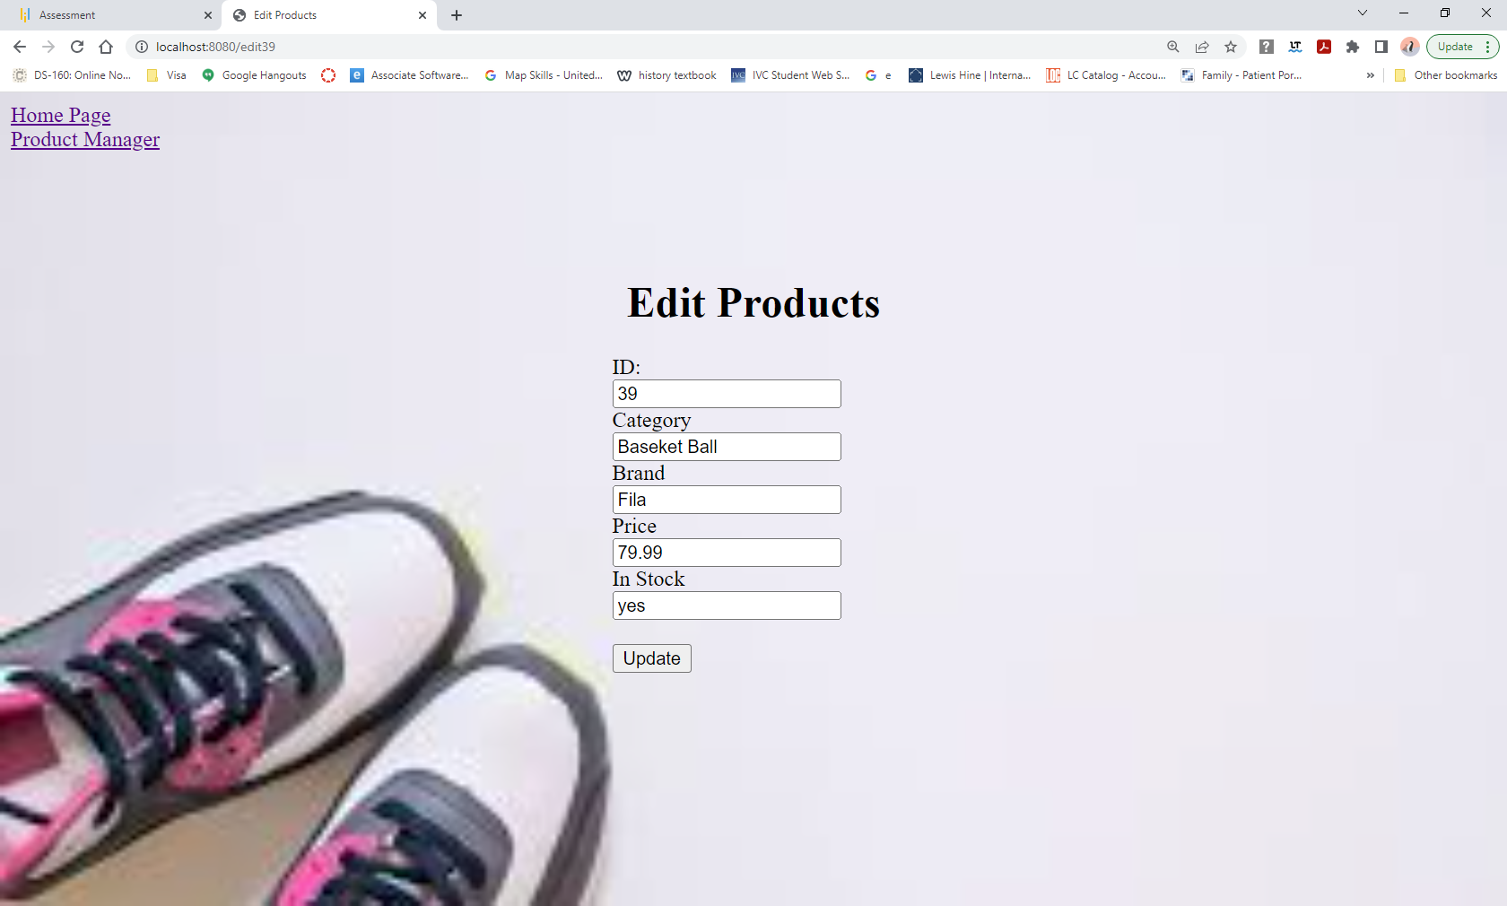

**Search Users Page:**

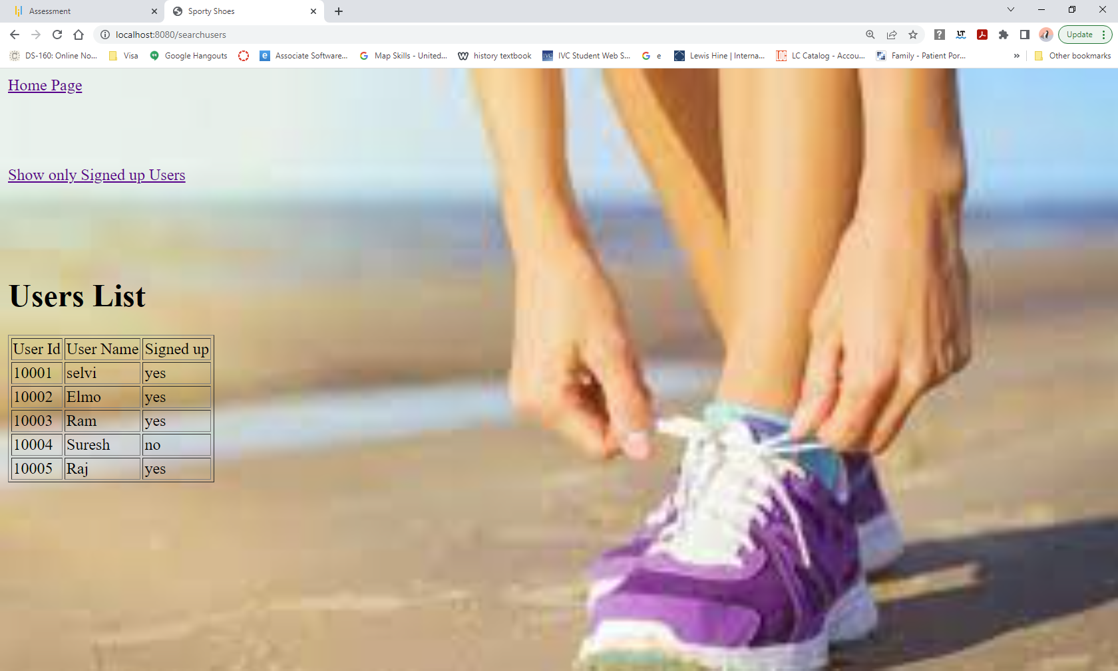

**Show only Signed up Users Page:**

